Assignment: 4
Asfa Ali
BSAI_3B_126
Task: 1
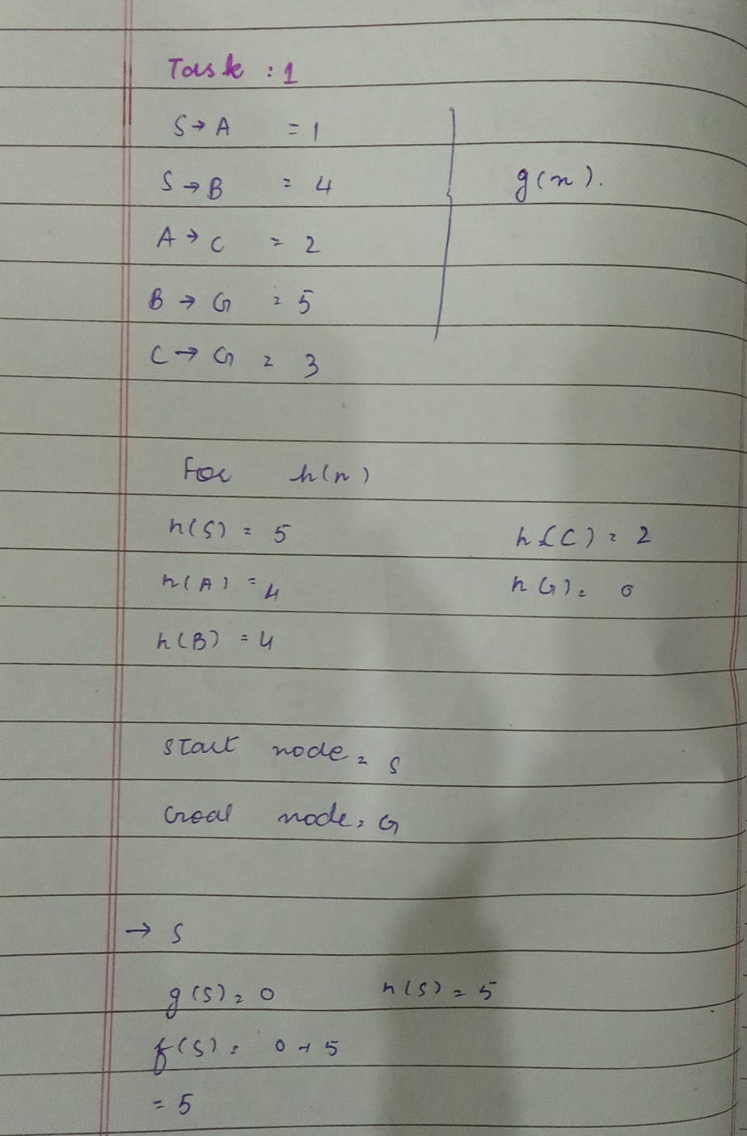
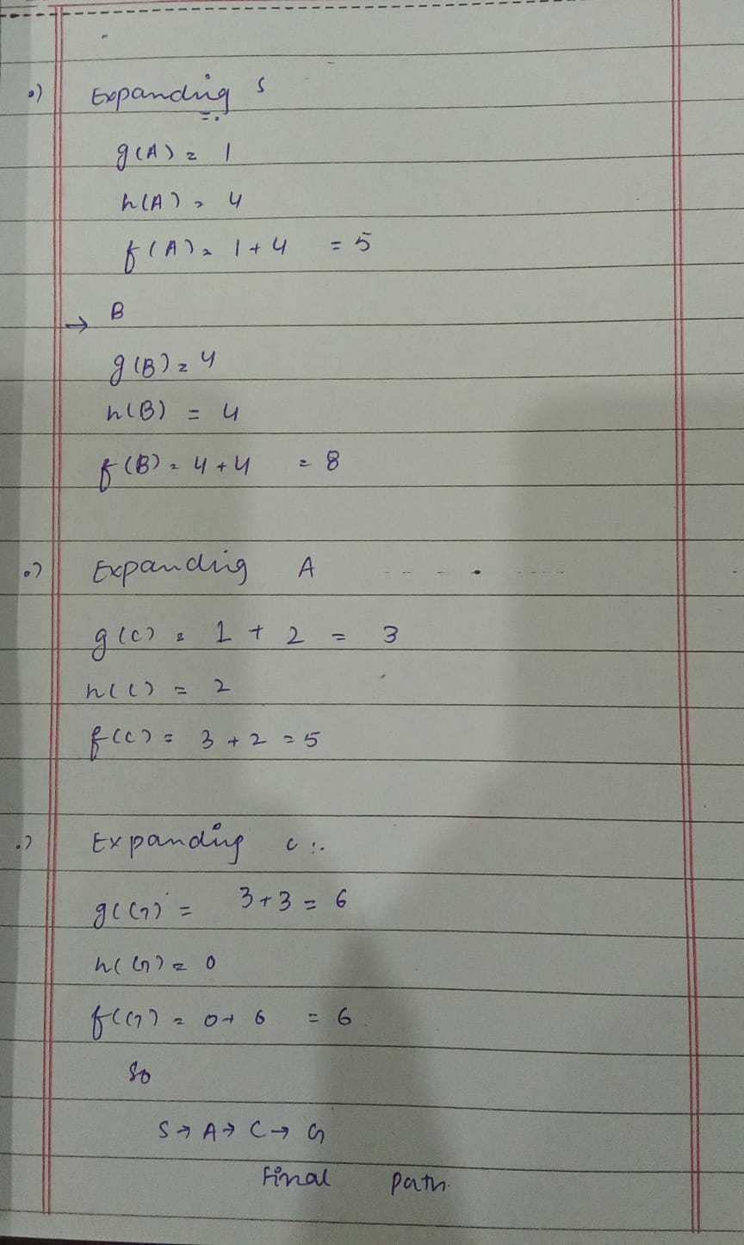

Queue Selection & Tie-Breaking Rule:
Rule: A∗ selects the node from the priority queue with the lowest f-value (f=g+ h). If f-values are tied, priority is given based on lower g-value and the natural order in which successors are generated and pushed.

Explanations for Each Step:
- After expanding S: Select Node A because its f-value (5) is strictly lower than Node B
- After expanding A: Select Node C because its f-value (5) is lower than Node B
- After expanding CCC: Select Node GGG because its f-value (6) is lower than Node B (8), reaching the goal.

